https://github.com/jadenthenanalyst/CMPR114-VScode/tree/main/Week%205/HW

**#1 print screen the output with code below here.**

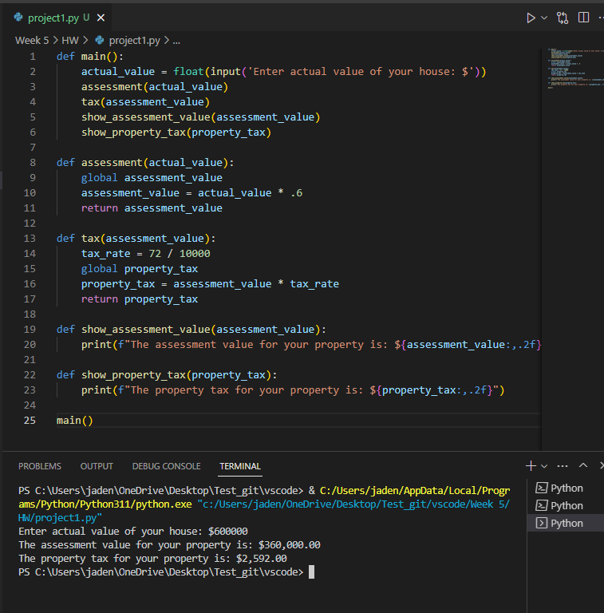

**#2 print screen the output with code below here.**

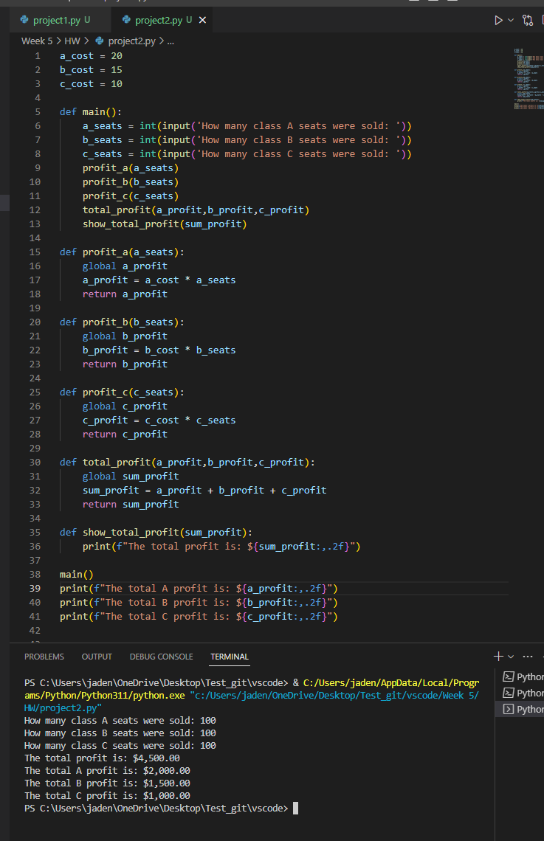

**#3 print screen the output with code below here.**

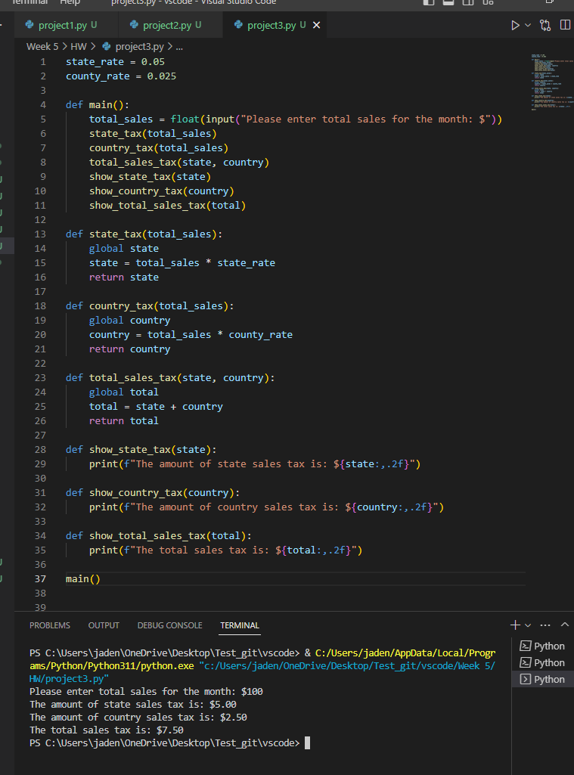

**Submit this document to Module 5 Homework**